Initial dataset has 469 fastq files genotyped at 352 loci and a sex marker. 43 duplicate fastq files with repeat sample_simple IDs are positive controls.

Look at concordance between 43 positive controls and their corresponding samples:

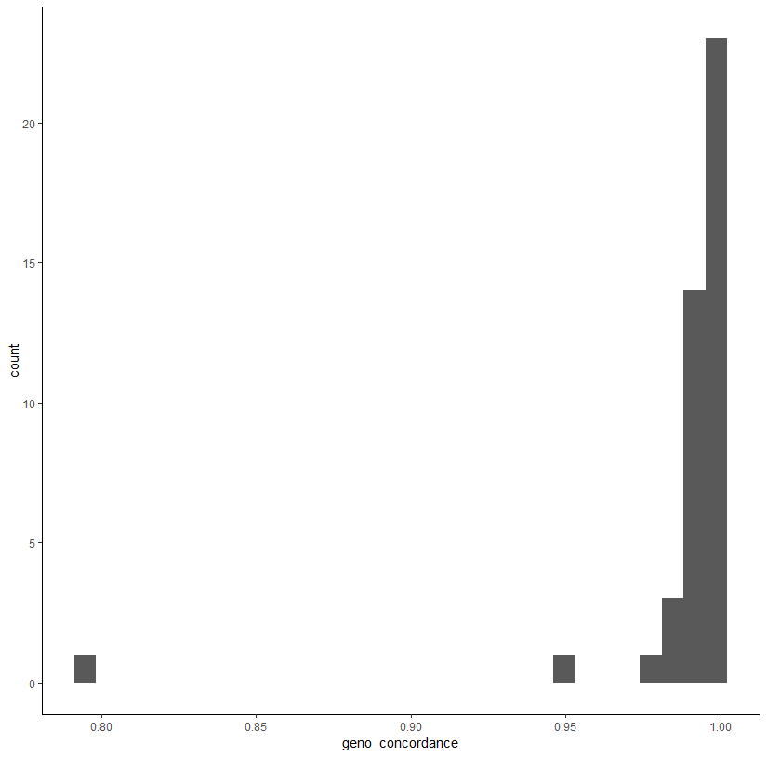

##concordance between quality controls and corresponding samples is high (0.8 - 1.0)##

Kept duplicate samples with the higher genotyping success. Removed duplicates with lesser genotyping success.

##dataset now has 426 unique samples genotyped at 352 loci and one sex marker##

Check sex genotypes:

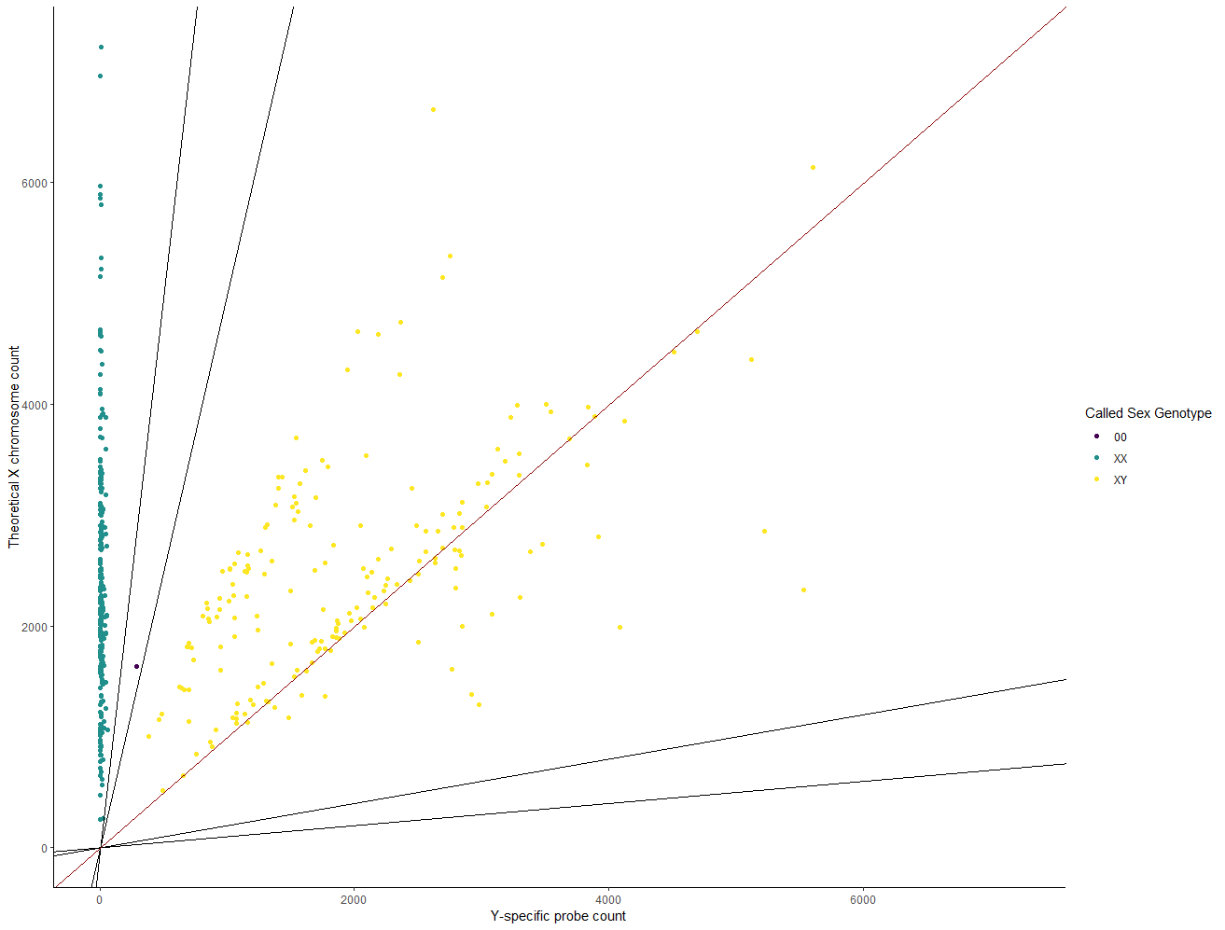

###Sex marker looks good. Leave as is without "correction" script##

Filter individuals/markers based on call rates/IFI scores:

Initial IFI scores. Most ok, some poor scores.

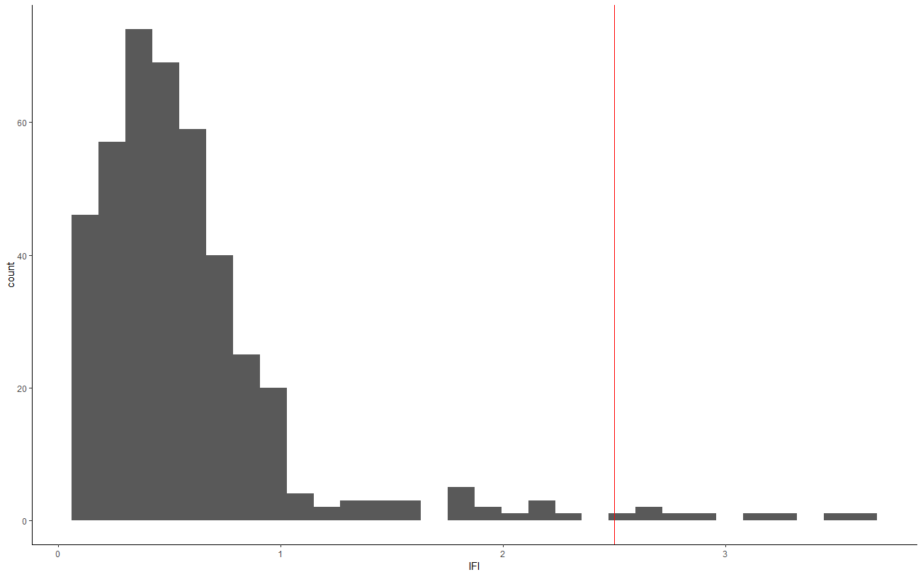

Most individuals are well genotyped. A few with less than 90% call rates

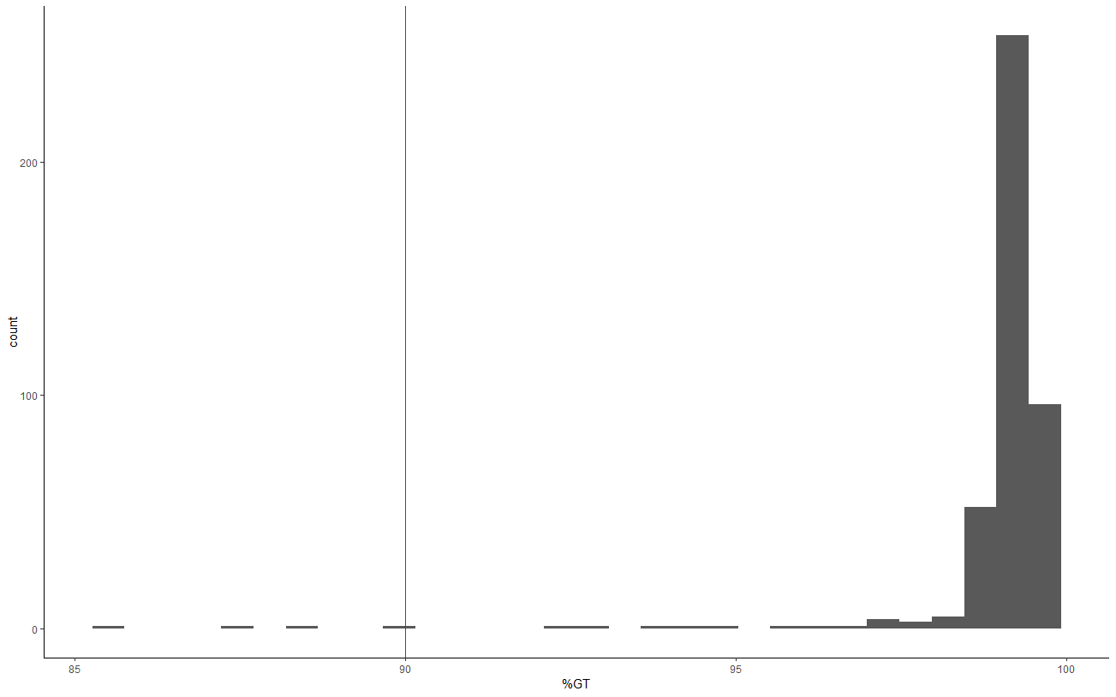

Most loci are well genotyped. A few missing in more than 20% of individuals. One (Ots_wenYhap_33126) not genotyped in any individual.

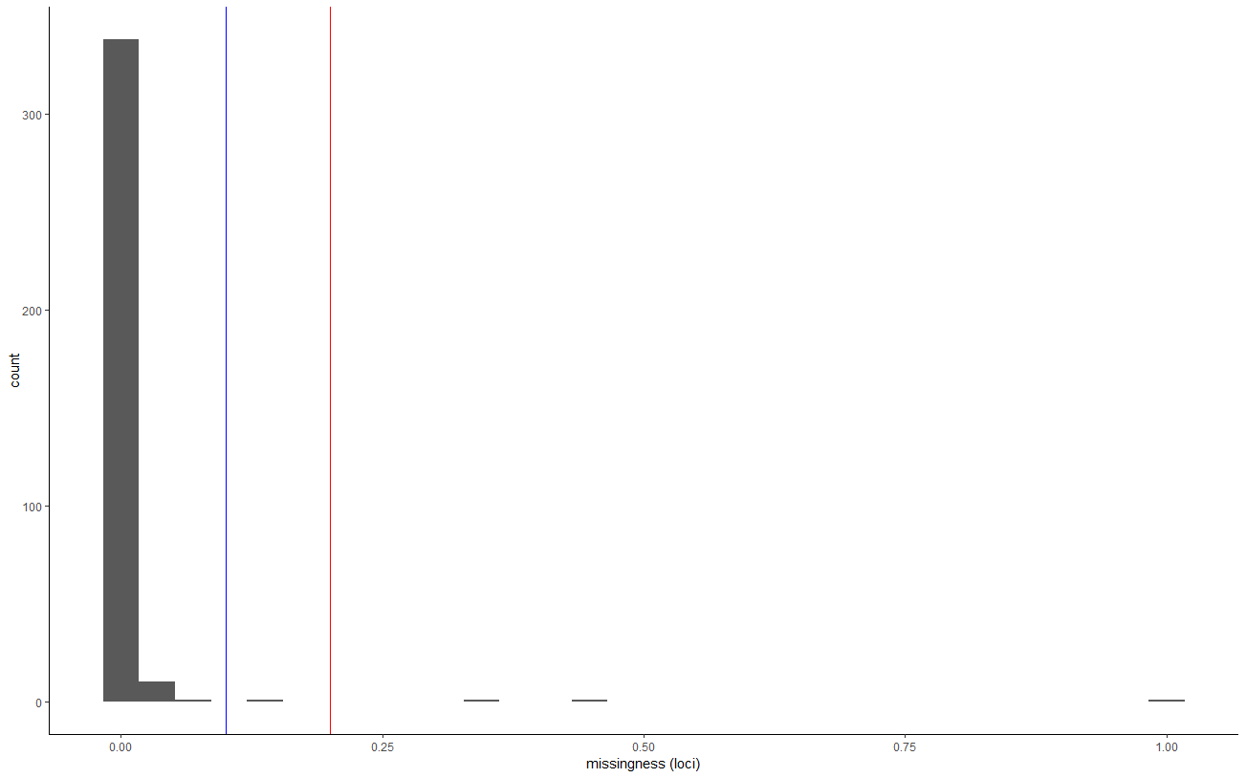

Removed locus not genotyped in any individual. Recalculate individual call rates.

3 individuals have call rates below 90%

OtsAC22COQR_0020 OtsAC23COQR_0177 OtsAC23COQR_0239

Removed these 3 individuals. Recalculate locus level call rates.

2 markers missing in more than 20% of individuals

(Ots17_1066109_C6 & Ots17_1486479_C6).

Removed these 2 markers. Recalculate IFI scores.

5 individuals have IFI scores greater than 2.5

(OtsAC22COQR_0039 OtsAC22COQR_0062 OtsAC22COQR_0096 OtsAC22COQR_0114 OtsAC23COQR_0193)

Removed them.

##At this point the dataset has 418 Individuals and 349 loci and a sex marker##

##Individual call rates range 94 - 100%; Marker call rates range 86 - 100%

##IFI ranges 0.09 - 2.25##

Evaluate for potential PSVs:

##6 markers are potential paralogs

"Ots_wenYhap_106664_9", "Ots28_11143508", "Ots37124-12281207", "Ots_TLR3", "Ots_afmid-196", "Ots19_46172427"

Removed them.

Quantify pairwise genetic distance among all individuals to identify repeat sampling.

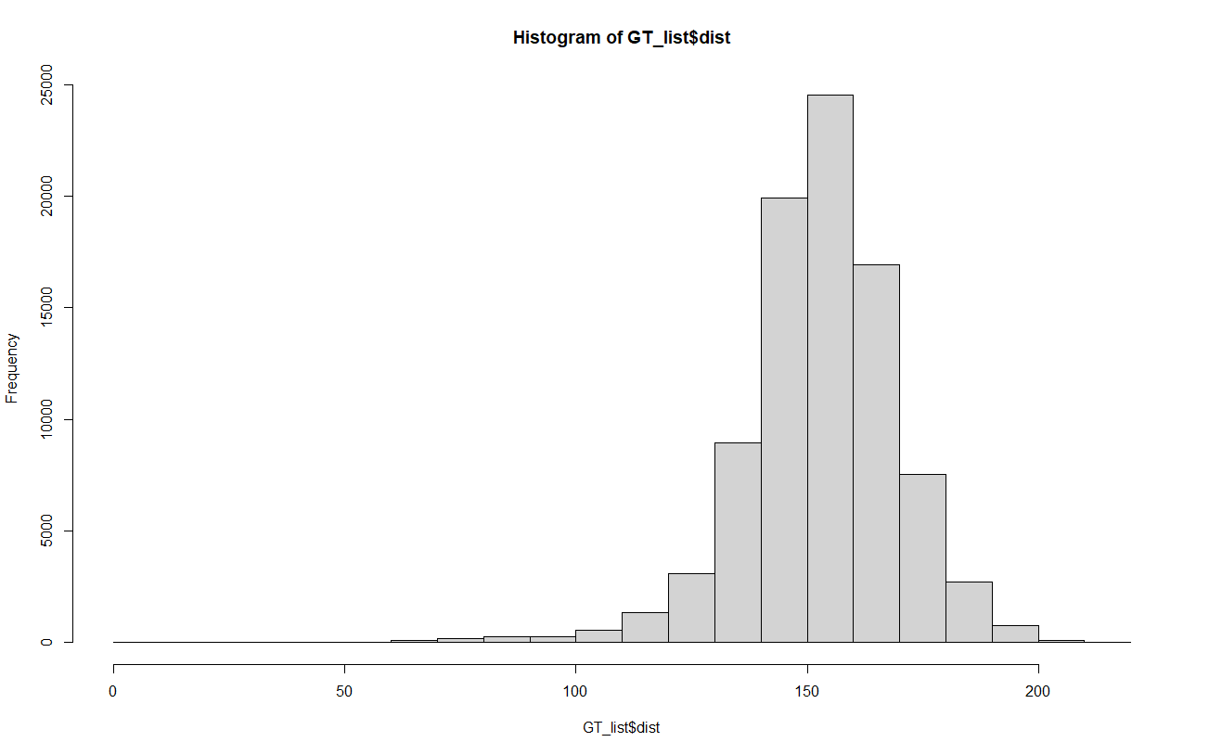

11 pairs of individuals have genetic distances below 50.

X1 X2 dist

4991 OtsAC22COQR_0013 OtsAC22COQR_0069 0

14029 OtsAC22COQR_0037 OtsAC22COQR_0068 0

27487 OtsAC22COQR_0076 OtsAC22COQR_0095 0

50313 OtsAC23COQR_0038 OtsAC23COQR_0055 0

56775 OtsAC23COQR_0104 OtsAC23COQR_0107 0

59659 OtsAC23COQR_0116 OtsAC23COQR_0117 0

62573 OtsAC23COQR_0128 OtsAC23COQR_1215 0

64951 OtsAC23COQR_0139 OtsAC23COQR_1217 0

67219 OtsAC23COQR_0150 OtsAC23COQR_1230 0

73473 OtsAC23COQR_0186 OtsAC23COQR_0202 0

76663 OtsAC23COQR_0207 OtsAC23COQR_1214 0

For each pair grabbed the sample with higher call rate.

16 monomorphic markers

Ots3_57055518 Ots_105401-325 Ots_GH2 Ots_IGF-I_1-76 Ots_IL8R_C8 Ots_IsoT Ots_NFYB-147 Ots_crRAD23631-48 Ots_crRAD26081-28 Ots_crRAD46751-42 Ots_tpx2-125 Ots_txnip-321 Ots_u07-64_221 Ots_wenYhap_25067_92 Ots_wenYhap_71572 Ots_zn593-346

At this point the dataset has 407 individuals (2022 n = 106 ; 2023 n = 301) and 327 markers and a sex marker.

Depth summary:

mean median sd

1684 977 2181